Steps to implement terrain:  
  
#1) Scene hierarchy > right click > 3D object > Terrain  
#2 ) Import files  
#3 ) Click terrain > Inspector window > edit terrain layers > create layer > select crash_backup_06_20_2023_15_40_11_Colormap_0_0.png  
#4 ) Change Tile Settings to 1000 x 1000  
#5 ) Change Normal Scale to 0.43  
#6 ) …  
#7) Profit!!!

**(scroll for screenshots for more info)**

Gifs sent in discord chat has these transforms. We can change the scene around to have a better background. I’m not married to these values!  
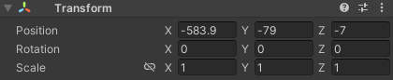

Steps for fog:  
#1) Window > rendering > Lighting  
#2) Lighting window > environment >  
 Realtime Shadow Color #8C6BA0  
 Fog Color #C5ACBC  
 Density 0.001  
